# The Counting Ourselves logo of a circle with the poutama design next to the words Counting Ourselves

# **Summary of findings for Māori**

# **from the 2022 Aotearoa New Zealand**

# **Trans and Non-binary Health Survey**

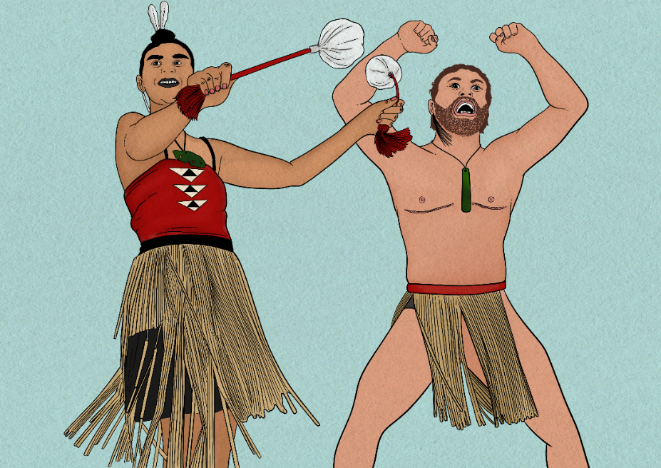

## A circular image with spiral designs in the centre called a Puhoro. Puhoro is a design that comes from the paddles of a waka hitting the water and leaving the spiral design in its wake. It is meant to represent the more general idea of fluidity. About the survey

Counting Ourselves is a comprehensive national survey of the health and wellbeing of trans and non-binary people aged 14 and older living in Aotearoa New Zealand. Our second survey took place between 1 September and 14 December 2022. It was completed by 2,631 trans and non-binary people, and one in seven (14%) were Māori.

## About this factsheet

This is a summary of key findings from the 366 Māori trans and non-binary people who completed the 2022 Counting Ourselves survey.[1] It is based on material contained in our second community report published in February 2025.[2]

We have only reported differences between Māori and the overall Counting Ourselves sample if they are statistically significant.[3] This means we have not covered some large sections of the community report where there were very few or no statistically significant differences for Māori. For example, Māori participants’ experiences trying to access gender affirming healthcare were similar to the community report’s findings for trans and non-binary people overall.[4]

We acknowledge Dr Tāwhanga Nopera, who led the Kaupapa Māori-informed approach that underpins the Counting Ourselves surveys. The Counting Ourselves community report draws on Te Whare Takatāpui*,* a Kaupapa Māori framework created by Professor Elizabeth Kerekere as a vision for takatāpui and rainbow people’s health and well-being.[5] Te Whare Takatāpui is made up of six values, with each one representing a different part of a wharenui (ancestral meeting house): Whakapapa (genealogy), Wairua (spirituality), Mauri (life spark), Mana (authority/self-determination), Tapu (sacredness of body and mind), and Tikanga (rules and protocols).

The community report has further details about Te Whare Takatāpui and groups recommendations under the six values, including specific measures to support Māori trans and non-binary people and organisations, their whānau, and Māori health providers. Counting Ourselves plans to do further analyses of Māori data for a separate Māori report.

The images in this factsheet and community report are by Huriana Kopeke-Te Aho.

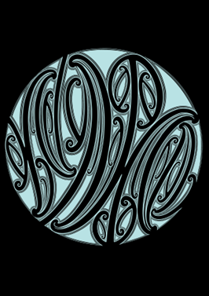This factsheet includes data about some difficult topics, including violence and suicide. If you or anyone you know is distressed, you don’t need to deal with this alone. There are people who are willing, able, and available to help you. Free call or text 1737 any time, call OutLine on 0800 688 5463 any evening between 6pm and 9pm, or refer to the other support services, including Māori organisations, on the Counting Ourselves website: [**https://countingourselves.nz/support/**](https://countingourselves.nz/support/)

## Māori who answered the survey

The Counting Ourselves survey was answered by 366 Māori aged between 14 and 71.

We asked Māori participants if they knew the name(s) of their iwi, with space to provide their iwi and region details. Most (298 people, 81%) provided the name of their iwi, with many listing more than one.[6] Māori participants came from more than 80 different iwi, from all parts of Aotearoa. The six most common responses Māori gave to this iwi affiliation question were, in order, Ngāi Tahu / Kāi Tahu (20%), Ngāpuhi (15%), Ngāti Porou (14%), Ngāti Kahungunu (10%), Ngāti Maniapoto (7%), and Tainui / Waikato-Tainui (7%).[7]

We gave participants a list of terms and asked them to indicate which ones they used to describe their gender. The most common te reo Māori term used by Māori was takatāpui (33%), much more often than other terms listed including whakawahine (9%), irawhiti (9%), tāhine (7%) or tangata ira tāne (5%). Māori participants could also write in any additional te reo Māori terms, and all the terms are shown in this word cloud.

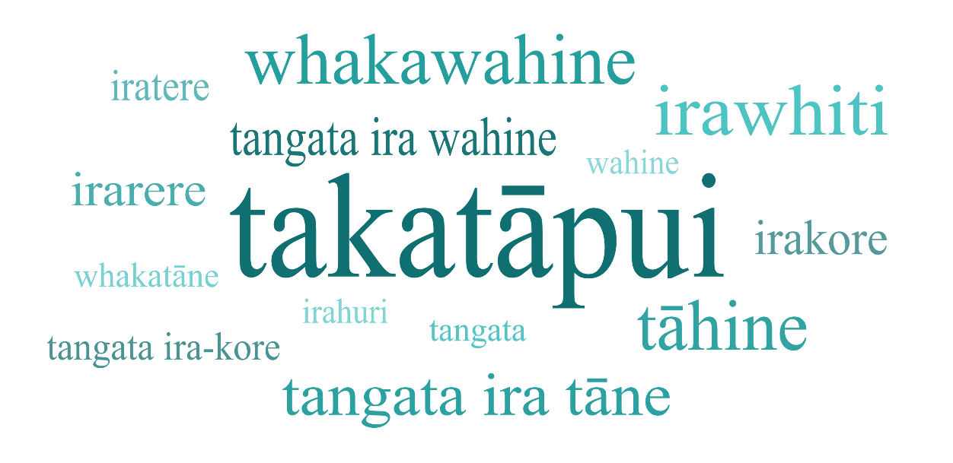

The most common pronouns Māori participants used to describe themselves were they/them (53%), followed by he/him (36%), she/her (30%), and ia (21%).

## Intersecting Māori and transgender identities

We asked all participants who identified as Indigenous, a person of colour, or who were from an ethnic community about experiences related to their cultural and gender identities.

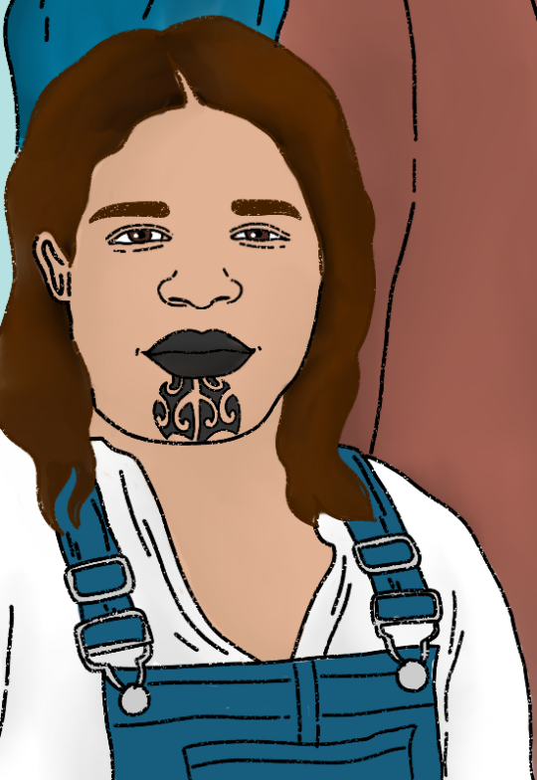**Most Māori participants (87%) *somewhat* or *strongly agreed* that they were proud of their cultural and gender identity.**

*“My takatāpuitanga has helped me better understand and love myself. Knowing that shame and fear around queer and trans identities is inherited from a colonial legacy has helped me connect better with my own spirituality and embrace a way of being that was passed down from my ancestors.”* (Non-binary, Youth)

*“Queer spaces can sometimes feel very exclusionary and challenging to access if they aren’t intersectional or educated about racism and decolonisation*.” (Non-binary, Youth)

There were some differences in how Māori participants responded to these questions compared to the larger group of survey participants who were Indigenous, a person of colour, or from an ethnic community.

### More likely to report some positive experiences of connection

Māori were more likely to *somewhat* or *strongly agree* that their **identity helps them feel connected** to both their cultural identity and their gender identity (70% vs 59%).

### Less likely to report some negative experiences of disconnection

Māori were less likely to report negative experiences of disconnection from their cultural community. They were less likely to *somewhat* or *strongly agree* that they:

* **can’t be open about their gender identity** within their Indigenous or ethnic communities (39% vs 54%)
* **feel unwelcome** within their ethnic or Indigenous communities **because of their gender identity** (40% vs 52%).

*“…often in all of the communities that I belong to (LGBT+, Te Ao Māori) I do not feel welcome simply for being part of the other communities I belong to. It makes me feel alone on a daily basis as part of me genuinely does not believe that I can find community, even in those who have the same intersectionality as me.”*

(Non-binary, Youth)

## Whānau

Most Māori participants reported these **positive experiences with their whānau**:

* 63% said that at least half of their family were **supportive of them being trans or non-binary**
* 61% had whānau members who used their **correct pronouns**
* 60% had whānau members who used their **preferred name.**

*“My Auntie showed me she accepted and approved of my transition (she was from a conservative Māori community) by sitting with me and talking about the river for hours. She emphasised the way it belonged to me and I belonged to it, that it was ever-changing and unfixed.”*(Trans man, Adult)

Māori participants also reported these **positive examples of support from their partners:**

* 72% said their partner had **told others to use their correct name or pronouns**
* 51% said their partner **reduced contact with people who were not supportive of their gender**
* 49% said their partner **stood up to people who put them down** for being trans or non-binary.

### More likely to have these negative family experiences

However, Māori who had disclosed that they were trans or non-binary to their families were more likely than all survey participants (the overall sample) to have these negative experiences with family members who would:

* **insult, mock, or put them down** (52% vs 37%)
* **ignore them** (36% vs 26%)
* **exclude them from family events** (25% vs 15%)
* **make a sexual comment about them** (20% vs 11%)
* **be violent towards them** (13% vs 7%).

Māori youth aged 14 to 24 were more likely than the overall sample to have family members who did **not allow them to wear clothes that matched their gender** (43% vs 26%).

*“Most of my family accept me but a few key family members are hostile and monstrous. Because I refuse to accept the cruel members of my family, the rest of my family treat me differently and sometimes are cruel to me because I do not welcome hostile people into my life.”* (Trans woman, Adult)

*“All my family are supportive but my family on my dad’s side of the family are very Christian so while they are supportive I still feel like they’re disappointed in me.”* (Trans man, Youth)

## Conversion practices

### More likely to have had these conversion practice experiences

Māori were more likely than the overall sample to say someone had ever tried to stop them from being trans or non-binary in these ways:

* 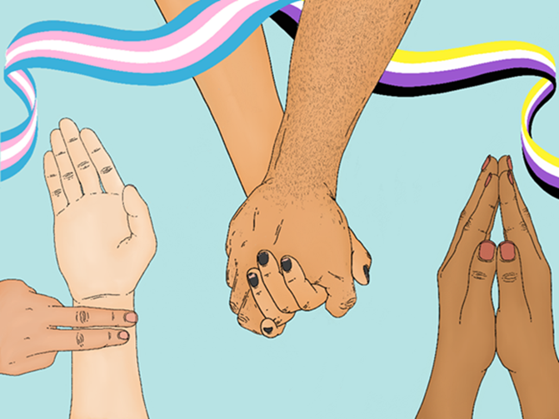trying to **shame or coerce them into gender-conforming behaviour** (42% vs 33%)
* trying to **teach them to be something else instead** (42% vs 30%)
* trying to **make them believe that their gender identity or expression was a defect** (37% vs 25%)
* trying to get them to **pretend that they weren’t trans or non-binary** (33% vs 22%)
* telling them they had to **stop being trans or non-binary if they wanted to practise their religion** (16% vs 7%).

Māori (21%) were also more likely to say that these actions were done by a **religious or faith-based organisation or person** compared to the overall sample (14%).

*“Was subjected to ECT and light and sound aversion therapy, prior to that was talk therapy.”* (Trans woman, Adult)

*“Physical and sexual abuse, medical treatments and folk remedies, anti LGBTQIA+ religious stuff, threats to send me to reform schools, threats of torture and death, telling me horror stories of medical misadventures that happened to people like me when accessing gender affirming healthcare, arranged marriage...”* (Trans man, adult)

*“My family, they have tried bullying tactics, emotional abuse, yelling, berating me, control me. Another is religion, using religion against me, when I came out as gay they would slip things under my bedroom door of what Christians think about homosexuality, how it was sinful. How I was excluded to do any type of leadership at the church. I tried to pray it away, seek support from pastors, suppress my queerness. I did not think because of how conservative my family is culturally and religiously that I could come out as gay, that prolonged the journey, I suppressed being trans well after my mid 20s thinking it was never possible and that being fluid was the best I could do to be happy*.” (Trans man, Adult)

*“My dad wasn't acting in any institutional or religious or organised way, although he was persistent, fixated and violent in trying to enforce what he wanted. So, I don't know if this counts as a conversion practice or not. But I think it had the same or similar effect. It has been very damaging.”*(Non-binary, Adult)

## Physical Violence

### More likely to have experienced physical violence or threats

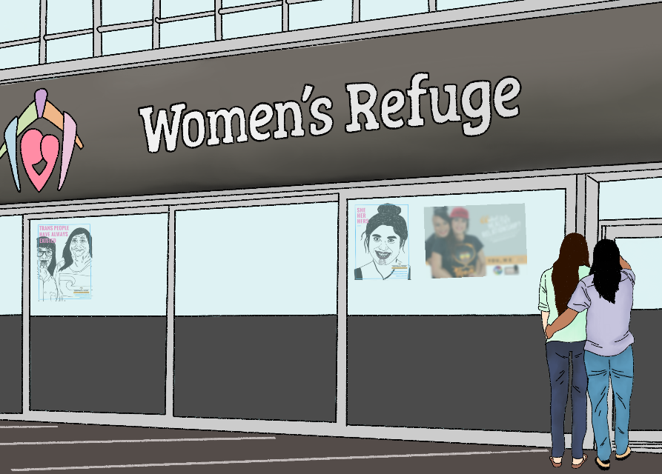Māori were more likely than the overall sample to have *ever* experienced:

* **Threats** **of physical violence**, including when someone threatened to use force or violence on them, or to physically harm them in any way (65% vs 54%)
* **Physical violence**, including when someone deliberately used force or violence on them, or physically harmed them in any way that frightened them (58% vs 46%).

*“During the first lockdown our own whānau were fine, we just were lonely. During the second lockdown we had to stay with in-laws with a brother-in-law threatening to hurt us and that whānau tolerating his behaviour. It affected us really badly.”*

(Non-binary, Older adult)

## Sexual Harassment and Violence

### More likely to have experienced sexual harassment and violence

Māori were more likely than the overall sample to have *ever* experienced **unwanted or offensive sexual contact** (76% vs 62%), or **another type of sexual harassment** (53% vs 38%).

Māori were more likely to have *ever* been **forced to have sexual intercourse** (57% vs 42%). Māori trans and non-binary people were more than twice as likely to have this happen to them compared to women (25%) in the general population.

Māori were more likely to report that someone had **forced them, or tried to force them, to have sexual intercourse when they did not want to** *in the* *last 12 months* (11% vs 5%). Māori participants reporting this were more than seven times more likely to have attempted suicide over that year (52%) compared to Māori who did not have this experience of sexual violence (7%).

Māori who had *ever* had a romantic, dating, or sexual partner were more likely than the overall sample to have had a partner:

* **do things to them sexually that they did not want** (48% vs 39%)
* who **objectified their body**, seeing them only as an object and not as a person (44% vs 34%).

## Safety

### More likely to feel unsafe

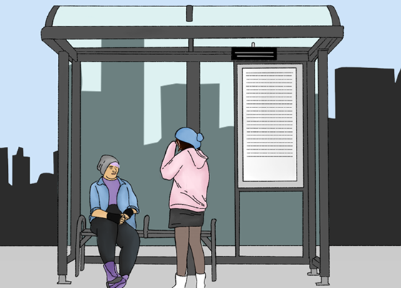Considering Māori trans and non-binary participants were more likely to experience physical and sexual violence over their lifetime, it is not surprising that they were more likely to feel unsafe in many situations than our total Counting Ourselves sample.

*“Basically I don't go anywhere these days, mostly because of COVID and being a caregiver for someone at risk, but also because of anti-trans hostility.”*(Trans woman, Adult)

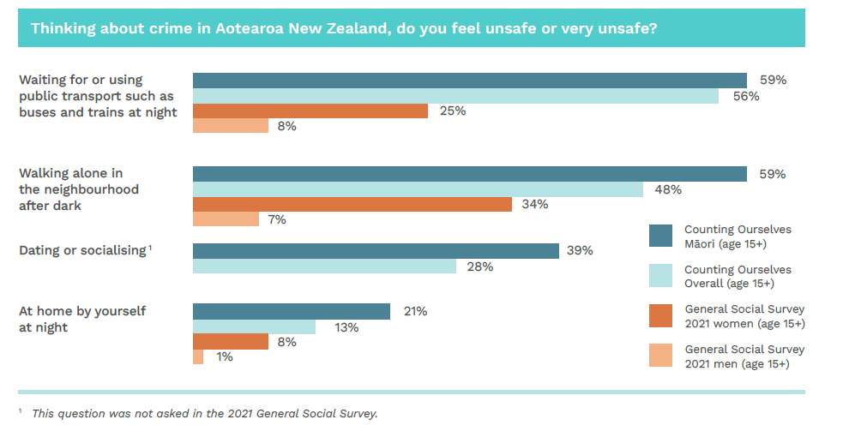

## Housing and material hardship

### More likely to experience homelessness, and to need emergency housing

A person sleeping on somebody else's couch, with an open suitcase on the floor.

Māori were more likely than the overall sample to have *ever*:

* **experienced homelessness**[8] (31% vs 19%)
* needed to access an organisation for **emergency housing**, including a shelter or refuge (25% vs 14%)
* **moved cities or towns** in Aotearoa New Zealand **to feel safer as a trans or non-binary person** (23% vs 16%),

*“Ended up homeless because of unsupportive family. Over a year later, I'm still homeless and just had a brief break where I had my own place but it's been hard being trans and not being on hormones for majority of the time because I've been harassed on the street for it.”* (Trans man, Youth)

### More likely to experience this material hardship

Māori aged 15 and older (58%) were also more likely to report needing to **go without fresh fruit or vegetables** *in the last 12 months* to keep costs down, compared to the overall sample (49%) and the general population (20%).

## Mental Health

### More likely to report considering or attempting suicide

Māori were more likely to report:

* they had **seriously considered suicide** at least once *in the last 12 months* compared to the overall sample (63% vs 53%)
* they had **attempted suicide** *in the last 12 months* compared to the overall sample (16% vs 10%).

*“I have the fear that when I reach out for help people will just say it’s my gender that’s making me suicidal.”* (Trans man, Youth)

*“Since starting hormones/gender affirming therapies, external pressures (family, friends, social, work, cultural) have contributed significantly to my mental distress at times.”* (Non-binary, Youth)

## Substance Use

### an image of a Māori trans person with a water bottleMore likely to have used cannabis, hallucinogens, and vapes

*In the last 12 months*, Māori aged 15 or older were more likely to have used:

* **Cannabis** (52%) for recreational or other non-prescription reasons, compared to the overall sample (43%) and the general population (15%)
* **Hallucinogens** (20%) for recreational or other non-prescription reasons, compared to the overall sample (15%) and the general population (3%)
* **Vapes or used e-cigarettes** at least monthly (32%), compared to the overall sample (18%) and the general population (8%).

*“I used substances from ages 12-16 (17?), mostly cannabis and MDMA but have experienced heavier substances. This was during a time where I had no support system being LGBT and had been sexually assaulted.”* (Non-binary, Youth)

*“I was an IVD user of opiates for many years, well before I transitioned, but when I knew I was trans. I had been chronically suicidal for a long time and used opiates to buy me enough time to find something to keep me alive. In the end what ended the suicidal ideation was transitioning, although I had fortunately been clean for many years by that point.”* (Trans man, Adult)

*“Available substance abuse prevention clinics are often very religious and unsafe for trans people because of religious discrimination.”* (Trans woman, Adult)

## Trans community connection, support, and leadership

### Positive levels of community connection

Community connection and supporting other trans and non-binary people were important to most Māori participants:

* 82% tried to **make things better for other trans and non-binary people**
* 69% felt **connected** to other trans or non-binary people
* 67% spent a lot of time **providing support** to other trans or non-binary people
* 59% felt a **part of a community** of trans or non-binary people.

*“I am grateful that there is language and visibility now of trans and non-binary lives, as when I was younger I felt very alone, invisible and unable to describe who I am. I love seeing and hearing from some of our rangatahi who are more easily able to be who they are and look forward to when we can all just be ourselves. I love that there are now recognised pathways for gender affirming health care and likewise look forward to seeing these just be.”* (Non-binary, adult)

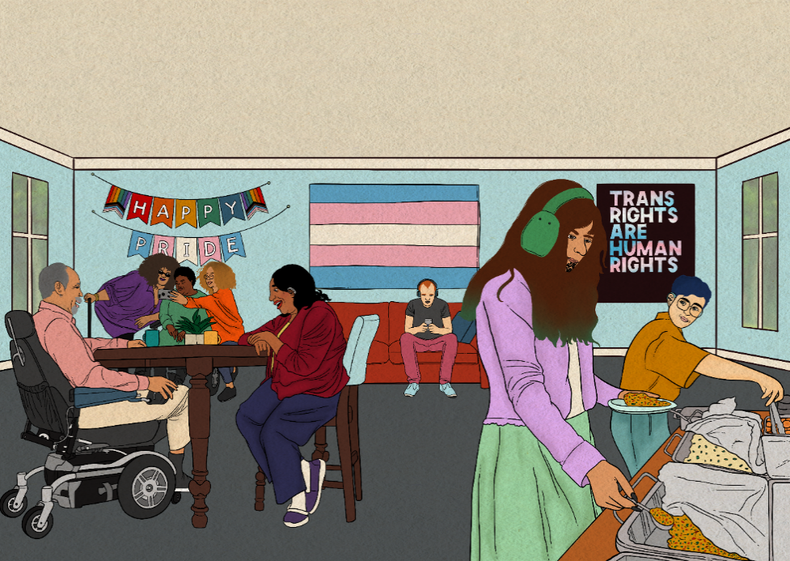

## Sense of Belonging

### Stronger sense of belonging to their ethnic group

We asked participants to rate their sense of belonging in different areas of their life on a scale of zero to ten. Below we compare the average score for Māori participants with the average score for all our survey participants and the general population.

* Māori (5.2) reported a stronger sense of belonging to their **ethnic group** compared to the overall Counting Ourselves sample (3.9)
* However, this was a weaker sense of belonging compared to the general population (7.8) in the 2021 General Social Survey.

*“I have one close friend who is also trans and Māori. I envy his connection with his culture and the way it influences his gender and identity, even though it comes with its own difficulties. I wish I wasn't so disconnected from my ancestors.”* (Trans man, Adult)

*“It's difficult being Māori but ‘not looking’ Māori. It's also difficult being in Māori spaces or situations where everything is very gender-binary heavy. Thank goodness for pronouns like ia because it gives me some hope.”* (Non-binary, Youth)

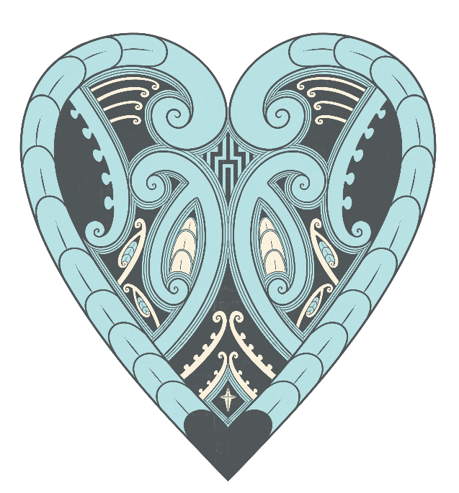*“Community means more to me than anything. Being able to connect to people that are like me and not like me has been the best experience I've ever had in my life. Feeling love is so important. I think love and connection is so important. This reaches out to everyone too. Once I found a strong network of trans people around me I was able to connect with and build strong networks with other people outside of this community that I hadn't really had the ability to do so before that. With a strong foundation I have been able to connect with cis and straight people which I hadn’t been able to. Very, very healing.” (*Trans woman, Youth)

1. This includes anyone who selected Māori as their ethnicity, including those who selected other ethnicities as well.
2. Both this factsheet and the community report are on our website, [www.countingourselves.nz](http://www.countingourselves.nz)
3. When we have compared Māori participants to the Aotearoa general population, we have not tested for statistical significance. The community report has further details about the survey methodology.
4. In a few sections of the factsheet, we have included some descriptive statistics for Māori only. There is no comparison given to other survey participants because the differences are not statistically significant. The purpose of these descriptive statistics is to provide some background context or to share some positive data about Māori participants’ experiences.
5. Kerekere, E. (2023). Te Whare Takatāpui – Reclaiming the spaces of our ancestors. In Green, A. & Pihama, L. (Eds.), *Honouring our ancestors. Takatāpui, two-spirit and Indigenous LGBTQI+ wellbeing*. Te Herenga Waka University Press.
6. So, while 298 Māori answered this question, when we added up all the iwi listed, we had a total of 460 responses.
7. For this factsheet, we have only combined the Ngāi Tahu and Kāi Tahu responses together and combined responses that said either Tainui or Waikato-Tainui. We realise there are overlaps between some of these six responses, and also with the many other iwi responses people gave. Counting Ourselves is keen to do more detailed analysis of the iwi affiliation responses, in collaboration with others, as part of work on a full Māori report. 
8. We used the Stats NZ definition of homelessness, which is a living situation where people with no other options to acquire safe and secure housing are: without shelter (e.g., sleeping without a roof over your head, or in your car), in temporary accommodation (e.g., renting a room at a motel, or staying at a homeless shelter), sharing accommodation with a household (e.g., couch surfing at friends’ homes), or living in uninhabitable housing.