# **Conclusion & recommendations**

Counting Ourselves provides comprehensive data about the health and wellbeing of trans and non-binary people in Aotearoa New Zealand. In this second Counting Ourselves community report, we analysed survey responses from 2,631 trans and non-binary people aged from 14 to 86, living all over Aotearoa New Zealand in 2022. With more than double the number of participants we had in 2018, we can draw strong conclusions and recommendations, including about whether progress has been made in the four years between then and our 2022 survey.

In this report, we have presented a range of findings about trans and non-binary people’s:

* physical and mental health compared to the general population
* experiences accessing general or gender affirming healthcare in primary care clinics, hospitals, and other healthcare settings
* access to gender affirming healthcare for those who wish to take these steps
* experiences of stigma, discrimination, violence, and lack of safety, including due to conversion practices
* ability to participate and be fully themselves, including at school, at work, and when playing sport
* pride in themselves and connections to community, including how this intersects with other parts of their identities, and
* support from friends, family, partners, and others and how this might protect against the negative impacts of stigma, discrimination, and violence that many trans and non-binary people face.

In many of these areas, we have seen very limited progress between 2018 and 2022.

Recent research in Aotearoa New Zealand shows a concerning rise in harmful, false information about trans people, especially trans women.[1] This has been linked to a 42% increase between 2022 and 2023 in reports to police of hate incidents targeting people based on their gender identity.[2] Misinformation about trans and non-binary children and young people and threats to gender affirming healthcare may also be hurting trans and non-binary people’s mental health.[3]

With these growing barriers and challenges, the Counting Ourselves team has worked to highlight ways to focus on the possibility of better health and wellbeing for trans and non-binary people. We have chosen to draw on Te Whare Takatāpui*,* a Kaupapa Māori framework created by Professor Elizabeth Kerekere as a vision for takatāpui and rainbow people’s health and wellbeing.[4]

## **Te Whare Takatāpui**

Te Whare Takatāpui is a framework that describes both the process and result of building a better future for takatāpui and rainbow people. It is made up of six values, with each one representing a different part of a wharenui (ancestral meeting house):

* 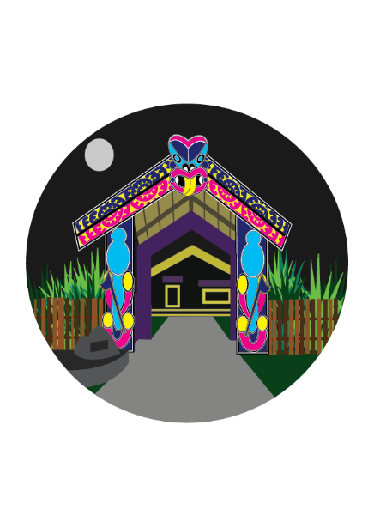Whakapapa (genealogy)
* Wairua (spirituality)
* Mauri (life spark)
* Mana (authority/self-determination)
* Tapu (sacredness of body and mind)
* Tikanga (rules and protocols).

When these values are woven together Te Whare Takatāpui can shelter and nurture all people whose genders, sexualities, or innate variations of sex characteristics differ from majority norms, and their whānau. In this final section, we have used these values to share our main recommendations and more detailed actions that have emerged from our survey findings.

### **Whakapapa**

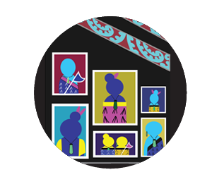   
  
Whakapapa is about genealogy and the tūpuna (ancestors) we descend from, and therefore the whenua (land) we belong to. Whakapapa is about the whānau we were born into, the whānau we choose, and the relationships that sustain us. In Te Whare Takatāpui, whakapapa is represented by the photographs of those we have lost, hanging on the walls. Even if we do not know the names of our tūpuna takatāpui, we know they existed, and we honour them.

Whakapapa reminds us that takatāpui have always existed, including those who might be referred to today as trans or non-binary. We remember and honour where we came from and all those who came before us, as we focus on building a whare (house) where trans and non-binary whānau can flourish. Whakapapa reminds us to recognise how colonisation has affected people. It also helps us to understand how the historic view of gender diversity as a mental disorder, and ongoing discrimination and false information about trans and non-binary people, can harm their health and wellbeing.

Recommendations and actions related to the value of whakapapa are to:

1. Develop resources and programmes that help people understand and celebrate gender diversity including by:
   * documenting Indigenous, pre-colonial, and other traditional views affirming takatāpui, MVPFAFF+, trans, non-binary, and other rainbow people, and
   * portraying the ethnic, cultural, religious, age, and disability, as well as gender diversity of trans and non-binary communities.

### **Wairua**

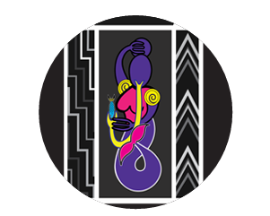   
  
Wairua refers to the spiritual dimension: the soul or essence we are born with that exists beyond death. In Te Whare Takatāpui, Wairua is represented by the whakairo (carvings) of our tūpuna, kaitiaki (guardians), and tipua (shapeshifters). The marakihau (water creature) depicted here is inspired by Hine Te Ariki, who became a marakihau after her death.

Te Whare Takatāpui recognises that a person’s gender identity comes from their wairua and that gender diversity is a positive and natural part of human diversity. Affirming and inclusive practices have positive impacts on the health and wellbeing of trans and non-binary people and their whānau.

Recommendations and actions related to the value aspect of wairua are to:

1. Fund accessible community spaces where people can feel safe enough to be themselves, embracing their takatāpui, MVPFAFF+, rainbow, trans, or non-binary identities.
2. Protect and support trans and non-binary people who have experienced attempts by others to change or suppress their gender identity or expression, including by:

* providing holistic and culturally appropriate support for those who have experienced family rejection, violence, discrimination, or conversion practices
* providing education about the harm caused by conversion practices, including information for families and in languages other than English, and
* monitoring progress in eliminating conversion practices, including the role played by education, support services, and legal prohibition.

### **Mauri**

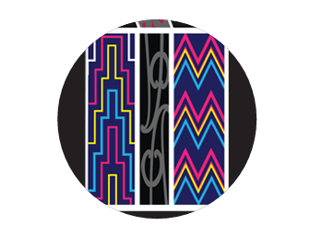   
  
Mauri is our life spark, that essential quality   
that is ours alone. Unlike wairua that exists beyond death, our mauri is born and dies with us. In Te Whare Takatāpui, mauri is represented by the tukutuku panels with their diversity of woven pattern and colour. These patterns are Poutama (left) and Kaokao (right).

Te Whare Takatāpui acknowledges the unique mauri of each trans and non-binary person and the right to be accepted for who we are. Trans and non-binary people need to be respected and valued in all areas of life, including at the doctor, in schools, when getting housing support, and on official documents.

Recommendations and actions related to the value of mauri are to:

1. Ensure health, education, housing, and other services treat trans and non-binary people with respect and understanding, and respond to trans and non-binary people’s needs, including by:
   * hiring more trans and non-binary workers in healthcare, including peer health navigators and peer support workers
   * creating accessible resources that share the experiences and needs of disabled trans and non-binary people
   * raising awareness and providing support for neurodivergent trans and non-binary people to reduce the barriers they face getting gender affirming healthcare
   * providing education and resources about gender diversity to healthcare providers who diagnose and work with neurodivergent people

* creating affirming resources for schools about trans and non-binary students’ rights to privacy, safety, and inclusion in activities like school sports, balls, and camps, and
* ensuring homelessness, emergency, and other housing services are safe, welcoming, and accessible for trans and non-binary people.

1. Enable all trans and non-binary people living in Aotearoa New Zealand to legally change their gender and name through a simple self-identification process, including by:
   * making it possible for trans and non-binary people born overseas to easily change their name and gender marker on New Zealand official documents, and
   * recognising the right to self-identification for non-binary people, by making sure there is a non-binary gender marker option on all official records.

### **Mana**

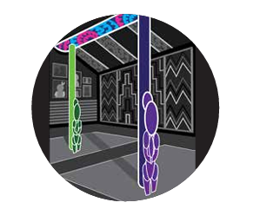

Mana refers to the authority, agency, and power we inherit at birth and that we accumulate during our lifetime through our words, deeds, and achievements. In Te Whare Takatāpui, Mana Wāhine and Mana Tāne are represented by the pou (posts) of the whare. Mana Tipua is represented by the tāhuhu (ridge pole).

Mana is about authority, dignity, respect, advocacy, and power. Te Whare Takatāpui upholds the mana of trans and non-binary people to make decisions and advocate for themselves and their needs. This includes providing information and resources for trans and non-binary people to make informed decisions about their health and wellbeing.

In Te Whare Takatāpui, Mana Tipua denotes the inherent mana of trans, non-binary, and intersex people and sits alongside Mana Wāhine and Mana Tāne. Mana Wāhine honours the inherent mana of women, including trans women and intersex women. Mana Tāne honours the inherent mana of men, including trans men and intersex men.

Recommendations and actions related to the value of mana are to:

1. Provide clear and transparent pathways to access gender affirming healthcare based on informed consent through the public health system, so people can get care quickly, no matter where they live in Aotearoa New Zealand.
2. Recognise and support trans and non-binary community leadership, including by:
   * involving trans and non-binary leaders and organisations in making decisions about trans health priorities and how care is provided, and
   * funding health and wellbeing initiatives led by trans and non-binary communities, including those specifically for Māori, Pasifika, Asian, other ethnic minorities, refugees and asylum seekers, disabled, young, and older people.
3. Share accurate information to counter harmful myths about trans and non-binary people through evidence-based resources and training about the inherent dignity of takatāpui, trans, and non-binary people and the importance of gender affirming healthcare.

### **Tapu**

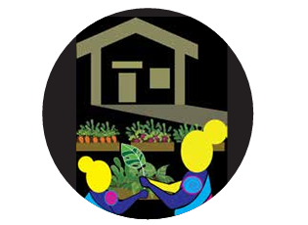   
  
Tapu refers to things that are sacred, things that are prohibited and are often breached in body and mind. Tapu placed restrictions in order to control how people behaved towards each other and the environment. In Te Whare Takatāpui, tapu is represented outside of the wharenui by rongoā, gardens, orchards, and quiet spaces for restorative practice and healing.

Te Whare Takatāpui recognises the harm, violence, and discrimination that many trans and non-binary people have faced and continue to face. Tapu reminds us how important it is to create safer spaces and provide care in a way that recognises and responds to trauma, as we strive to ensure people’s hinengaro and tinana are safe so they may recover and heal.

Recommendations and actions related to the value of tapu are to:

1. Make all types of gender affirming healthcare more available through the public health system, including:
   * counselling, hair removal, voice therapy, fertility preservation, puberty blockers, hormones, and surgeries, and
   * funding for longer GP and nurse practitioner sessions when supporting trans and non-binary people considering starting hormones.
2. Protect trans and non-binary people from violence by:
   * naming and addressing the specific issues trans and non-binary people face in strategies, policies, guidelines, training, and services to counter sexual and family violence and sexual harassment
   * providing appropriate training and guidance to agencies that respond to violence to make their services safe and accessible for trans and non-binary people, and
   * expanding access to community-led, culturally appropriate support services for trans and non-binary victims/survivors of violence.
3. Include trans and non-binary people as a priority, alongside other takatāpui/rainbow people, in mental health and addiction policies and programmes by:
   * naming and addressing the specific issues our communities face within action plans, policies, and programmes, and
   * funding counselling and other mental health and addiction initiatives, developed in partnership with trans and non-binary communities.

### **Tikanga**

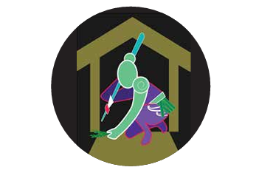   
  
  
Tikanga denotes the right ways of doing   
things and what happens if we do something wrong, based on the evolving mātauranga (knowledge) we have. In Te Whare Takatāpui, tikanga is symbolised by the paepae and marae ātea, the front of the wharenui from where the wero (challenge) is made. We collectively develop tikanga that is inclusive of all our generations and diversity.

In Te Whare Takatāpui, tikanga requires us to think about the systems and processes that will ensure the safety and flourishing of trans and non-binary people. This means collaborating with trans and non-binary community organisations and leaders to upskill kaimahi (workers) and rethinking policies and ways of working so they support trans and non-binary people.

Recommendations and actions related to the value of tikanga are to:

1. Fully protect trans and non-binary people from discrimination and harassment by*:*
   * strengthening legal protections in the Human Rights Act, and
   * providing training, resources, and policies about human rights including for schools, employers, sporting bodies, police, and other government agencies.
2. Provide training and resources about trans and non-binary people’s health needs to healthcare workers, including for Māori, Pasifika, Asian, refugee, perinatal, youth, disability, aged care, and rural health providers.

# **Next steps**

In this community report, we have provided vital data about the situation for trans and non-binary people in Aotearoa New Zealand in 2022, including many comparisons to findings from our first survey in 2018. This helps build a strong case for long overdue changes needed in laws, policies, and services.

In 2021, our Counting Ourselves data were cited by the then Prime Minister when announcing the first national funding for mental health support services for rainbow young people.[5] That same year, our survey data about the unmet need in access to gender affirming healthcare was included in Ministry of Health policy documents that suggested steps to address those gaps.[6] Some funding for health initiatives for trans people was included in Budget 2022.[7] These included small local projects delivering gender affirming healthcare in primary and community settings, the development of national guidelines to create national care pathways, and some workforce training for primary healthcare providers.[8]

However, these initial steps feel fragile, especially as trans and non-binary communities, and rainbow communities more broadly, remain overlooked in health priorities and action plans. We need commitments to addressing the ongoing gaps in access to gender affirming healthcare and to improving the overall health and wellbeing of trans and non-binary people. This will require national and regional leadership, working in partnership with trans and non-binary communities.

The findings from our second survey in 2022 highlight our shared responsibility to listen to and address the disparities, especially stigma, discrimination, and violence, that trans and non-binary people face. These issues are even more serious for specific groups within our communities, including disabled, Māori, Pasifika, and Asian people, and those from other ethnic community backgrounds. Further in-depth quantitative research and more qualitative studies are required to better understand the urgent needs of these groups, and also for a growing population of older trans and non-binary people.

We only had space in this community report to look at a fraction of the questions we asked in our 2022 survey. Our small team of part-time researchers and students is always seeking opportunities to collaborate with others. Together we could analyse and make available more Counting Ourselves data that can help our communities, service providers, and policy makers. As we finalise this report, we are excited to be working with others on a disability resource and we will be seeking funding to create reports for Māori and Pasifika communities.

We invite government agencies, health providers, community groups, researchers, and funders to collaborate with us to action the findings and recommendations of this report.

1. See Hattotuwa et al. (2023) in Selected Resources.
2. See the NZ Police’s Te Raranga partnering programme to reduce the harm caused by hate in Aotearoa New Zealand: <https://www.police.govt.nz/advice-services/advice-victims/hate-motivated-crime/te-raranga-weave>, including its published data: <https://www.police.govt.nz/sites/default/files/publications/nia-data-on-offences-non-criminal-incidents-flagged-perceived-hate-motivation.pdf>
3. See Lee et al. (2024) in Selected Resources.
4. See Kerekere (2023) in Selected Resources.
5. See <https://www.beehive.govt.nz/release/first-ever-nationwide-funding-mental-health-services-rainbow-young>
6. See <https://www.health.govt.nz/system/files/2022-06/h202117552_response.pdf>
7. See <https://www.beehive.govt.nz/release/rainbow-health-gets-funding-boost>
8. See Professional Association for Transgender Health Aotearoa (2023), p. 5, in Selected Resources.