Conclusion and recommendations
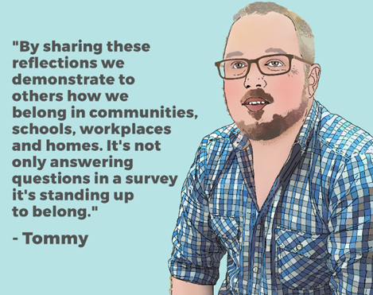
By focusing specifically on trans and non-binary people and asking about a comprehensive range of health-related topics, Counting Ourselves has been the first survey of its kind in Aotearoa New Zealand. Key strengths of this survey are that it was led by trans people with guidance from a trans and non-binary community advisory group, it had a large number of participants from across the country and we are able to compare the results with key health indicators from population-based surveys.

This is the first time we have quantitative data from trans and non-binary people living in Aotearoa New Zealand for many of the topics covered in this report. Our findings illustrate the stark contrast and health inequities between trans and non-binary people and the general population, especially in the areas of mental health and wellbeing, including the very high rates of psychological distress and suicide attempts within our communities.

Access to healthcare
One of the goals of this research project was to explore possible reasons for these health inequities. This report shows many trans and non-binary people cannot access medically necessary gender-affirming care. This care is often simply not available within the public health system. Other barriers we identified include cost, lack of information about how to access services, long waiting lists and gaps in health providers’ knowledge about gender-affirming care. Participants described other barriers they faced when they were trying to access healthcare. These included being asked unnecessary or inappropriate questions and being referred to by the incorrect name or gender, which meant that many participants delayed or avoided seeking care.

Discrimination, violence and hardship
Our findings illustrate the huge personal impact of the stigma that people face for being trans or non-binary. Counting Ourselves participants reported widespread discrimination, especially in public places, trying to find a job or housing and at work. Most did not have the correct gender marker on their identity documents, and many of these participants reported that this resulted in harassment and other negative and stressful experiences in many areas of their lives. We also found high rates of harassment and violence against trans and non-binary people, including by family members and partners.
Given the high levels of discrimination, harassment and violence, it was not surprising that we found high rates of material hardship among our participants.

Differences between groups
Trans and non-binary communities are diverse, so it was important for us to explore where there are different findings based on participants’ gender, age, region, ethnicity or whether they have a disability. These findings are reported as demographic profiles in this report.
Our findings show that those who also experience discrimination, harassment or violence for reasons other than being trans or non-binary (such as racism or ableism) were more likely to experience health inequities.
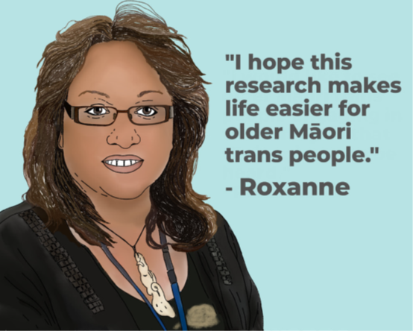
We found reasons to be hopeful for the future. Trans and non-binary youth were more likely to have grown up with a family/whānau member who helped them to legally transition or researched how best to support them. Participants who were supported by their family/whānau were also more likely to have positive mental health. Most participants were working to improve the lives of other trans and non-binary people through volunteer work.

Recommendations
In order to improve the health and wellbeing of trans and non-binary people in Aotearoa New Zealand, action is needed in all areas covered by this report. The evidence in this report supports the following eight high-level recommendations, many of which have previously been submitted to formal consultation processes within Aotearoa New Zealand or through reporting to United Nations’ human rights mechanisms.

1. Provide access to gender-affirming healthcare
- provide clear pathways, based on informed consent and self-determination, for timely access to gender-affirming healthcare through the public health system, including hair removal, puberty blockers, hormones, fertility preservation, voice therapy, counselling and mental health support and gender-affirming surgeries.
- provide access to training and resources to improve primary healthcare providers’ competencies for working with trans and non-binary people, including around gender-affirming care
- work with Māori and Pasifika trans and non-binary people to develop culturally appropriate services built on kaupapa Māori and holistic Pasifika models of care and wellbeing

2. Ensure health services respect gender diversity
- provide mandatory training for staff in DHBs, primary health organisations, disability support services and residential care facilities on supporting trans and non-binary people and promote health service environments that are respectful of gender diversity and are trans positive.

3. Improve trans and non-binary people’s mental health and wellbeing
- identify trans and non-binary people, and the broader rainbow population, as a named priority in the Government’s response to its 2018 Mental Health and Addictions Inquiry, including in national and regional mental health and addictions policies.

4. Support schools to be safe and inclusive for trans and non-binary students
- resource initiatives that assist schools to deliver high-quality, comprehensive sexuality and gender diversity education, undergo staff training on gender diversity and establish rainbow diversity groups
- address bullying against trans and non-binary students and adopt inclusive policies and practices for trans and non-binary students, especially around access to sports, bathrooms and changing rooms, including gender-neutral/unisex options for uniforms, bathrooms and changing rooms

5. Better protect trans and non-binary people from discrimination
- provide comprehensive resources and training about the human rights issues and protections for trans and non-binary people for health providers, schools, employers, government agencies and the wider public
- amend Section 21 of the Human Rights Act 1993 to explicitly include gender identity, gender expression and sex characteristics as specific prohibited grounds of discrimination
- review police policies and practices to ensure the dignity and safety of trans and non-binary people who have been detained, held in custody, arrested or charged by the police

6. Protect trans and non-binary people from violence, as a priority in anti-violence work
- recognise the specific experiences and needs of trans and non-binary (and other rainbow) people and communities in anti-violence strategies, policies and services
- provide appropriate training and guidance for all agencies that respond to sexual or domestic violence, to improve the safety and accessibility of their services for trans and non-binary people

7. Simplify processes for trans and non-binary people to have accurate health records and identification documents
- provide a third non-binary gender marker option on all administrative records including the National Health Index and electronic patient record systems
- adopt an accessible administrative process, based on self-declaration, for amending gender markers on birth certificates
- enable trans and non-binary refugees and asylum seekers on temporary visas to complete a statutory declaration to verify their self-defined gender identity and name

8. Support health and wellbeing initiatives led by trans and non-binary communities
- resource peer support and other wellbeing initiatives led by trans and non-binary communities including those developed by disabled people, Māori and Pasifika peoples, Asian and other ethnic minorities, and refugees and asylum seekers.

Next steps
This community report is the first analysis of responses to the Counting Ourselves survey. It includes rich information about risk and protective factors for trans and non-binary people’s health in Aotearoa New Zealand and offers a strong rationale and evidence base to advocate for changes needed.
Our research team is hugely aware of the context within which this survey was conducted. The recently announced Budget 2019 funding for genital reconstruction surgeries to reduce 50-year waiting lists was long overdue and welcomed. However, there appears to have been no additional provision for the many other areas of gender-affirming care where this report shows there are high levels of unmet demand. Until that occurs, trans and non-binary people are likely to continue to struggle to get the care they need.
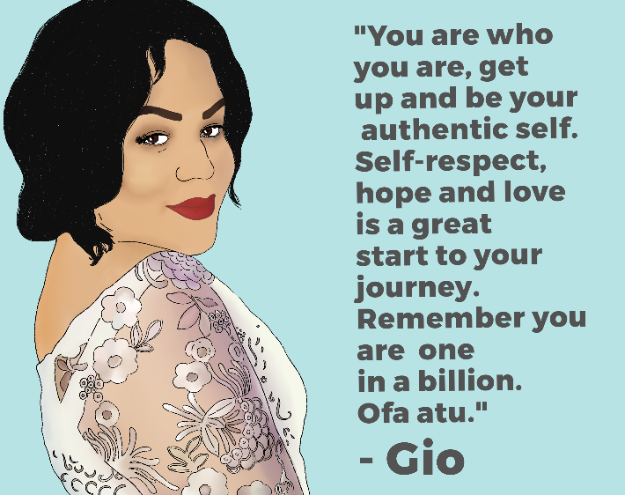
The Counting Ourselves participants were incredibly generous in sharing their fears and hopes, and it is vital that their voices are heard. If no action is taken, it risks reinforcing the perception that trans and non-binary people’s health and wellbeing is undervalued and current health inequities are acceptable.
We invite government agencies, health providers, community groups, researchers and funders to collaborate with trans and non-binary researchers to action the findings and recommendations of this report.

The recommendations about access to general and gender-affirming care draw heavily from the Guidelines for gender-affirming healthcare for gender diverse and transgender children, young people and adults in Aotearoa, New Zealand, published in October 2018.

