Disabled participants
Around a quarter of participants had a disability and many faced additional barriers when trying to access healthcare. Disabled participants were more likely to have put off visits to the GP in the last year due to the cost or because they did not have transport. They were also less likely be able to afford to access hormones, and to be told they could not access chest reconstruction surgery or a hysterectomy because of their age, body size or other reason.
Disabled participants had lower median incomes and higher levels of material hardship. This means they were more likely to have put up with feeling cold, gone without fresh fruit and vegetables or trips to the shops or repairing broken appliances. Disabled participants were also more likely to not be able to afford to change their name on IDs or records.
Disabled participants were more likely to have experienced discrimination in the last 12 months, either on the street/in a public place, in a shop or restaurant, or when seeking medical care. They were also more likely to have been treated unfairly or verbally harassed because they were trans or non-binary when using Work and Income services and avoided Work and Income because they thought they would be mistreated for this reason. Disabled students were more likely to report that adults at school did not care about them.
Disabled participants were also more likely to feel unsafe or very unsafe at home at night, walking alone in the neighbourhood after dark, waiting for or using public transport, or dating and socialising. They were twice as likely to report someone had sex with them against their will, at a rate seven times that for the overall Aotearoa New Zealand population.
Disabled participants were twice as likely to feel lonely most or all of the time in the last four weeks. Nine out of ten experienced high or very high psychological distress over that period. Almost two-thirds of disabled participants had deliberately self-injured in the last 12 months.
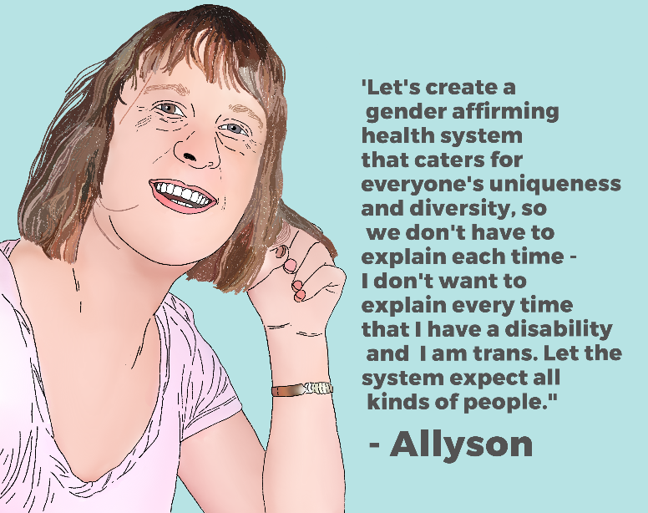
These findings show increased levels of hardship, discrimination, violence and isolation experienced by disabled trans and non-binary people, which could explain the severe mental health inequities that we found for this group. Despite this, disabled participants were more likely to socialise online with other trans and non-binary people. Disabled trans and non-binary people are leaders in demanding the need for change, and they were more likely to be involved in political activism than non-disabled survey participants.

